**CHAPTER III**

**PROBLEM ANALYSIS**

**III.1 Comparison Among Social Media Which The Best For Online Business**

Social Media is the best media for online business. As we know, alot of social media out there can be a media to promote reader business. Lot of people utililize social media to show their product via their account that created in the social media. If reader register at a social media that have a lot of user, the businesss will growth faster. Especially if reader company always broadcasting your business via a famous account or mentioning other user that has a similar interest with the product.

There are a comparison among Social Media which the best for online Business :

1. **Twitter**

Twitter is a microblog social media, reader can post something shortly. In 2010 – 2013 Twitter is a famous Social Media. Using twitter as media to promote the product is good at that years. But now people move from twitter, the reason is people want a social media that have a lot of feature. Twitter only has 140 characters to post and its very short, that’s the reason why people start to move on from twitter now.

1. **Facebook**

Facebook is a social media which famous at 2009 – now. People choose facebook because facebook has a lot of feature. With Facebook reader can make a group or community, fanpages or official page for reader company, and also facebook has a advertisement at right side if reader want to show the product or the company page there. Nowadays, Facebook is still trend in Indonesia and alot of people still using Facebook rather than twitter. The reason is Facebook has many feature than Twitter.

1. **Instagram**

Instagram is a social media to posting a picture. Nowadays people in Indonesia using intagram for endorsing (promote product), and show their account company product. As we can see, alot of our public figure like our Famous Actor, Public Figure and Famous Teenagers using instagram to business. Rather than show their activity or moment, they also business with other company in endorsing (promote product).

1. **Line**

Line is a social media like a BBM. Line is operate in Android OS. Line is choosen by alot of company because in Indonesia, there are alot of Line user. Line is good for social media business because they have a fanpages or official account pages like a facebook. Line also operate in Smartphone and people nowadays prefer playing Smartphone rather than PC (Personal Computer). The reason is smartphone is more flexible and simple rather than personal computer. Line Official Account or Fanpages also have a feature to broadcast their adders (user who add their Official Account). With powerful and alot of feature, Line is choosen by many people to promote their product, Especially for Consumer-to-Consumer method.

1. **Kaskus**

Kaskus is indonesian famous forum. In that forum we can do many things such as posting a technology thread, chat with other user on a group, or even sell our product there on sub forum called “Forum Jual Beli” (FJB). Kaskus is very suitable for online business because kaskus has a feature to make a thread and inside your thread you can post all of your product picture. So the customer can see the product that you sale inside your thread. Your product also will be put in a certain category. Example if a company sell MicroSd, Flashsdisk, Computer, Laptop then the thread will be put in inside the technology and electronic category. This division category make the product will be easily found because people who buy and search the product certainly are the people who understand and need items in technology or electronic.

**III.2 Advantages and Disadvantages of Business Online in Social Media**

1. **Advantages**
2. **Less Fund**

Using Social Media as a media of business can make company fund only spend less.That is because you don’t need to search a place to make the shop, reader doesn’t need rent a place to build the shop, and also reader doesn’t need fund if reader are a reseller of one product company such as wardah cosmetic company.

1. **Effective Marketing and Promotions**

This can happen because the companies or business use the social media to do marketing and promotion. For example there are a feature in Line@ (Official Account or Fanpages) called Broadcast, if a official account has many adders (line user who add that official account) they can tell anything or everything they want and the message will be recieved by their adders. Reader can show the product via advertisement on their broadcast and your product will known-well.

1. **No Matter The Distance**

No matter if reader are in Jakarta and the customer in Malang. Reader can still do a transaction because the product can be package and send via Freight Forwarding Service such as Tiki, Pos Indonesia, and JNE. The customer can transfer their money via bank and show the transfer evidence to reader.

1. **The Costs can be Reduced**

E-business can be used for those who want to reduce costs. Store operating costs, electricity costs, and salaries can be reduced because reader can do it by yourself. If reader are consumer to consumer business type, reader only need internet and the business will goes well.

1. **Disadvantages**
2. **Costumer Confidence**

If reader new with the online business via social media, reader need a long time to make a confidence to the costumer. Costumer rather choose the old seller rather than new shop without alot of testimonial. If reader sell product to the costumer and the costumer didn’t feel satisfied with the product, the product will be bad because they will tell your shop is bad to the other costumer.

1. **Many Competitors**

Don’t think there are only one company who sell Shirt or Phone in the Social Media. There are a lot of your competitors who sell the same product. To make the Business keep growth, you must use a unique tricks and promotion to make the customer keep choose your product. The quality of product also should be keep or increased if you want your customer keep chose your shop.

1. **Slow Respond**

This is happened if reader are a consumer to consumer business types. If the reader have online business, the reader will do it everything by yourself. Tell product to the consumer, send the package, check the transfer bank, check email, etc. Reader time will be divided to service between one customer to other customer. Sometimes there are a customer which didn’t patience, they want reader to fast respond to buy the product. If reader make a slow respond, surely that customer will runaway from reader shop and choose the other shop which has fast respond reply.

**III.3 Company Progress and Growth With Online Business**

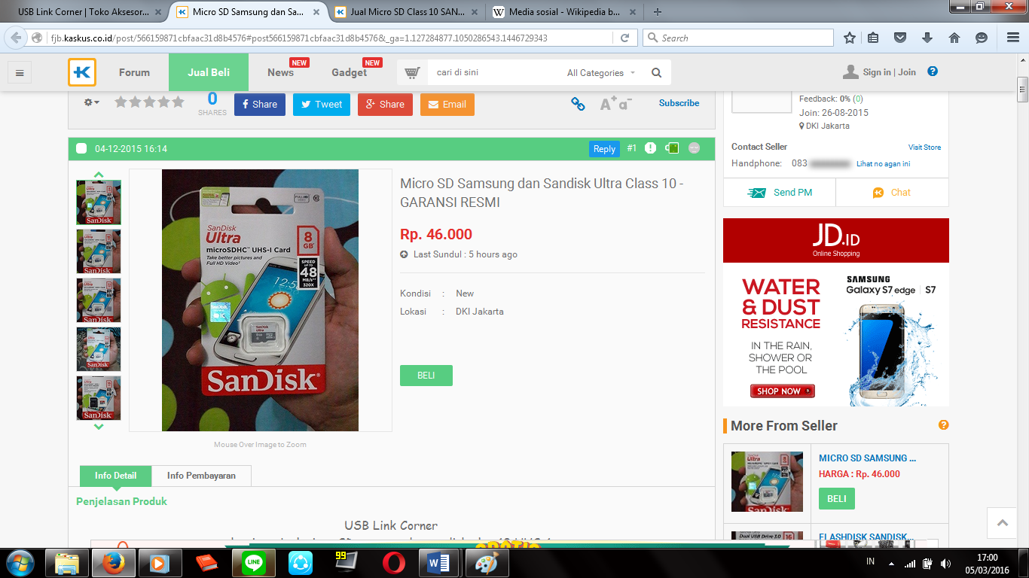

Figure 3.1 USB LinkCorner Flashdisk and MicroSD Seller on Kaskus

Ref : www.fjb.kaskus.co.id

Online Business make a person easily show their product to the customer. As example we make a interview with the owner of thread MicroSD seller which sell their product on Kaskus. His name is Bagus Yudo Hadiyanto and he is 23 years old. Bagus is a owner of MicoSD Seller thread on Kaskus. Bagus explain, that he is only a reseller and he doesn’t have a store outside there. Bagus only have a online shop. Bagus also didn’t work and focus only to his business. “At the start of business and little of fund, online shop is the best business because it more efficient and today average of people busy with their work and they don’t have a time to buy directly to shop” said Bagus. He said his business slowly increasing with the social media.

To make his business keep growth and increase Bagus always make a unique promotion from his online business. Bagus also tell us to make the customer confidence and satisfied with his service, he always try to reply and service the customer with fast respond in order to make customer feel satisfied with his service.